**Literature review:**

Now let’s dig a little bit deeper and explore the available solutions of this problem. The approach that we will take is simply to discuss the available solutions in web and mobile app technologies to each of the ten examples which are discussed previously in the “problem statement” section .

To show you what we mean let’s begin with the first example:

**Example one:**

“Ahmed is a visually impaired man, who can’t see well without the aid of others, he wants to communicate with a sighted person to read something for him.”

**Current Solutions:**

After doing some research about apps that helps visually impaired or blinded people, we found an app called “Be My Eyes” , and this is how it is introduced on its main website

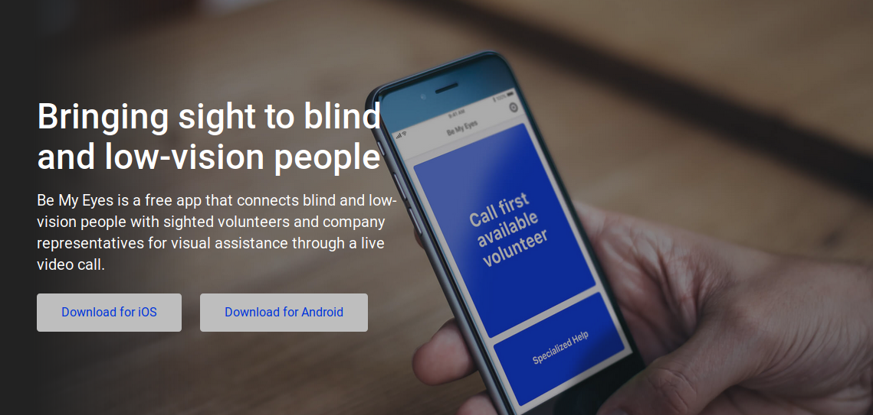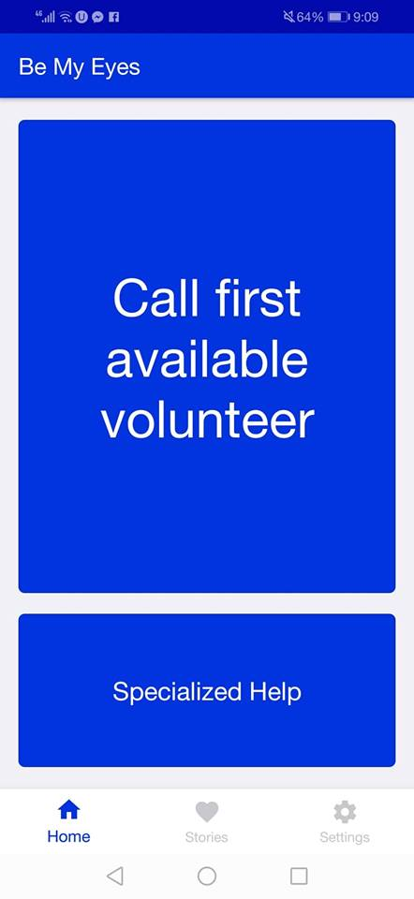

We noticed seven main things:

1-It’s a cross platform app, which means it runs on (android and ios).

2-The main idea of the app is to connect volunteers with visually impaired people, in order to help them.

3-It’s very accessible to the users, they can use microphone and camera to make voice or video calls to the volunteers. The action buttons themselves are large in width and font size.

4-The matching technique that connects users to volunteers is ***“the language”***.The app asks for your first language before you can get your request.

5-It took 38 seconds to reach the first English volunteer while experimenting the app. When we changed the language into “Arabic” it took around the same time, which is a very good timing indeed.

6-The app was released on oct 4,2017 which is about a year from the date we are writing this chapter on, the number of volunteers reached 1,809,689 volunteer, and the number of Blind & low-vision is 105,760.The ratio of volunteers to visually impaired people is 17 times, which is an amazing number relative to how recent the app is.

7-There is no focus on attractive design, but mainly on the functionality and speed.

**Examples: two and three:**

"khaled is reluctant to choose between different departments in his college, he wants to easily contact students in each department to help him taking a decision.”

“Mohamed is going to get a driving license , but he is too afraid of taking the test. He wants to chat with someone who experienced it before to tell him about the test circumstances, and all the procedures to be taken.”

**Current Solutions:**

The most popular way to connect with experienced people in a specific domain is using **facebook groups.**



By analyzing how things are going on these groups, we noticed the following:

1-People are matched together based on their **“interest in the same topic” .**

2-Requests or opinions are written in posts ,that are seen to the other members, which might be annoying to someone who likes privacy.

3-Questions in knowledge exchange groups may take up to one day or more without any response. Only you receive notifications from members who follow your question.

4-Connection through such groups is mainly through text, which is not very reliable, fast, nor easy.

5-Users can take advantages of old questions to find answers to their request.

6-It’s not easy to find some groups about specific topics if you aren’t already a member.

7-There is no reputation system or incentives for the users to reply.

*There are many other alternative platforms that help you connecting with experienced users, but the realized thing is that they are too technically oriented, and communication is also mainly through text.*

**Example four:**

“Abdelrahman wants to launch his own startup, but he can’t launch it alone as he needs another partners, how could he find trustworthy partners with the right qualifications for the startup, and initiate discussion with them?”

**Current Solutions: “Ideas voice”** is a website that helps you to find a cofounder.



We noticed the following :

1-Limited number of users.

2-The site has an **optional** verification system by checking the identification card, so verification is not guaranteed all the time.

3-You have to pay 25 dollars to get your identity verified.

4-Matching is done mainly by **location**.

5-To contact a certain cofounder, you have to fill your needs and write about your project, and we see that as unnecessary work.

6-No reputation system is founded.

**Examples five and six:**

“Doaa makes homemade food and sells it for others online, but she faces a problem of finding someone with a suitable price who can deliver her food to the customers.”

“Mariam is going to get married, she wants someone to move boxes of her belongings from her current home to her future home via a truck. She can’t find one easily.”

**Current Solutions:**

**“Taskrabbit”** is a popular website and application that defines itself as **“**The convenient & affordable way  
to get things done around the home”.



We noticed the following:

1-It generally deals with handy jobs.

2-It divides tasks into categories such as:

* Mounting and installations.
* Moving and packing.
* Furniture assembly.
* Heavy lifting.
* General Handyman.

3-It divides users into normal users and taskers.

4-People are matched together based on **“task categories”** (Point number 2).

5-The app is accessible, and many request are done successfully.

5-There are complaints that taskers have to pay money (20 dollars) to register.

6-There are complaints about customer services, and not handling accountability for taskers mistakes.

7-There are complaints about taskers cancellation and not showing up.

**Example seven:**

"Mona wants to buy a ticket to attend her favorite band concert but she is very busy and transportation is difficult, she just wants to find someone who can buy it for her and receive it from him/her later.”

**Current Solutions:**

There are some websites like **“stubhub”, “seetickets”, “Twickets”**.They define themselves as a fan to fan market, but in all of them we noticed the following:

1-They have very limited users.

2-Their coverage is mainly in US and UK .

3-**Searching for an artist, event, or team** is the main way to match you with ticket sellers.

4-In twickets website a 12% fee is taken on each bought ticket.

5-Some sites provides delivery of tickets , while others depend on the fans to handle delivery options.

6-In some of these websites there is a guarantee to cover for the full amount of tickets if they aren’t as described.

**Example eight:**

“Hussein wants to know what transportation to be taken to a certain destination, he googled it but he found outdated information. He wants to quickly contact anyone in this destination to help him figuring the most suitable transportation.”

**Current Solutions:** No specific solution is founded that involves human interaction.

Facebook groups might be a solution.

**Example nine:**

“Farid wants to rent the football field in his college, he doesn’t want to attend college this day because he and his friends are in vacancy,so he needs to find another student in the college to rent the field for him.”

**Current Solutions:** No specific solution is founded.

Posting in user’s profile on Facebook or using facebook groups might be a solution.

**Example ten:**

“Gamal is terribly shy, he can’t make any friends. He wonders if there is any way that he can find friends who share his hobbies and enjoy their time together.”

**Current Solutions:**

A solution for this problem is an app called **“patook”**, which defines itself as “strictly platonic”. It doesn’t allow approaching other users for romantic reasons, it’s all about making friends.

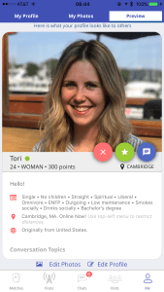

We noticed the following:

1-It has automated computer algorithms that detect unwanted contributions (e.g: flirt detector, spam detector,etc..).There is very minimal human moderation or support.

2-The app matches users according to i**nformation that they have to fill in their profile** like:

* Martial status.
* Offspring.
* Orientation.
* Ethnicity.
* Religion.
* Politics.
* Smokes.
* Drinks.
* Education.
* Diet.
* Personality type.
* Shyness.
* Astrological Sign.
* Country of origin.
* Languages.

It also supports adding keywords

3-The reputation system depends on points based on many things such as :

* Logging recently.
* Having a photo.
* Filling their profiles.
* Quick response.

4-There is a questionnaire that users can take. This allows Patook to assign “points” for user traits. Example, if you are looking for people who list museums and music on their page, they get more points and appear higher in your matches. This feature might feel overwhelming and distracting from user experience.

5-Complaints about customer support being unresponsive.

6-Complaints that detection algorithms are not very accurate.

**Now let’s discuss in the next section: what’s unsolvable yet?, and how can we modify the flaws in these solutions in order to reach a whole new solution to provide better and faster communication?**